TEAM ID:

NM2023TMID15874

MEMBERS:

M.ANU

R.KEERTHANA

S.SARANYA

V.VISHVA

PROJECT TITLE:

HR ANALYTICS WITH TABLEAU

PAPER TITLE:

DATA LITERACY WITH TABLEAU

DETAILS:

3 YEAR,

B.SC.MATHEMATICS,

PG& RESERCH DEPARTMENT OF MATHEMATICS,

KALAIGNAR KARUNANIDHI GOVERNMENT ARTS COLLEGE

THIRUVANNMALAI.

**Tableau** is a powerful tool used for data analysis, visualization. It allows creating amazing and interactive visualization and that too without coding. Tableau is very famous as it can take in data and produce the required data visualization output in a very short time. Basically, it can elevate your data into insights that can be used to drive your action in the future.

1. Data Exploration: Tableau allows you to explore your data in a visual and interactive manner. You can easily filter, sort, and drill down into your data to uncover patterns, trends, and outliers.
2. 2. Data Visualization: Tableau offers a wide range of visualization options, including bar charts, line graphs, scatter plots, maps, and more. You can choose the most appropriate visualization type to effectively communicate your data insights.
3. 3. Dashboard Creation: With Tableau, you can create interactive dashboards that consolidate multiple visualizations into a single view. Dashboards provide a comprehensive overview of your data and allow users to interact with the data to gain deeper insights.
4. 4. Data Collaboration: Tableau supports collaborative data analysis by allowing you to share your visualizations and dashboards with others. You can publish your work to Tableau Server or Tableau Public, making it accessible to colleagues, stakeholders, or the public.
5. 5. Data Storytelling: Tableau enables you to tell compelling stories with your data. You can create a narrative flow by combining multiple visualizations, annotations, and interactive elements to guide your audience through the data story
6. 6. Data Integration: Tableau can connect to a wide range of data sources, including spreadsheets, databases, cloud services, and more. This allows you to bring all your data together in one place for analysis and visualization.
7. 7. Data-driven Decision Making: By enhancing your data literacy with Tableau, you can make more informed decisions based on data insights. Tableau helps you transform raw data into

actionable information that can drive business or personal decisions.

Different visualizations:

1. KPI

2. Department wise Attrition

3. No. of employees by Age Group

4. Job Satisfaction Rating

5. Education Field wise Attrition

1.2 Purpose 1. Visualize Data: With Tableau, you can create stunning visualizations that bring your data to life. Whether it's charts, graphs, or maps, you can present your data in a way that's easy to understand and visually appealing.

2. Gain Insights: By analyzing your data in Tableau, you can uncover valuable insights and patterns. You can spot trends, identify outliers, and understand the story behind your data.

3. Make Informed Decisions: With data literacy and Tableau, you can make data-driven decisions. By exploring and analyzing your data, you can gain a deeper understanding of your business, customers, or any other area you're interested in.

4. Communicate Findings: Tableau helps you effectively communicate your data findings. You can create interactive dashboards and reports that allow others to explore the data on their own. It's a great way to share insights and collaborate with colleagues or stakeholders.

5. Optimize Performance: Tableau provides tools to optimize the performance of your data analysis. You can create calculations, apply filters, and use advanced features to get the most out of your data.

6. Identify Opportunities: By analyzing your data with Tableau, you can identify opportunities for growth, improvement, or cost savings. It helps you spot areas where you can make a positive impact.

7.Drive Data Culture: Tableau promotes a data-driven culture within organizations. It encourages everyone to engage with data, ask questions, and make decisions based on evidence.

1. Data Exploration: With Tableau, you can easily explore your data from different angles and dimensions. You can slice and dice your data to uncover hidden patterns and relationships.
2. Data Storytelling: Tableau allows you to create compelling data stories. You can combine visualizations, annotations, and narratives to create a narrative that engages your audience and helps them understand the insights you've discovered.
3. Collaborative Analysis: Tableau supports collaborative analysis, allowing multiple users to work on the same dataset simultaneously. It promotes teamwork and knowledge sharing, leading to more comprehensive analysis and better decisionmaking.

2. Problem definition and design thinking: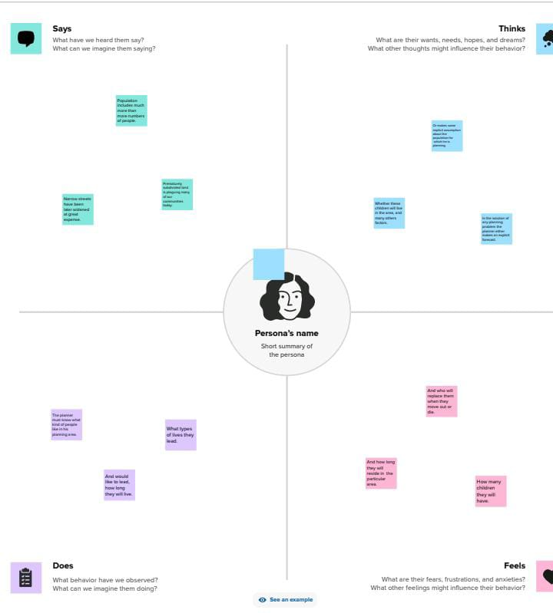

2.1 EMPATHY MAP

2.2 Ideation and Brainstorm map:

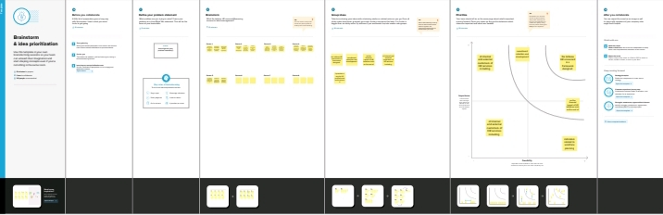

3.RESULT:

HR analytics is the process of collecting and analyzing Human Resource (HR) data in order to improve an organization’s workforce performance. The process can also be referred to as talent analytics, people analytics, or even workforce analytics.HR analytics is the process of collecting and analyzing Human Resource (HR)data in order to improve an organization’s workforce performance. The process can also be referred to as talent analytics, people analytics, or even workforce analytics

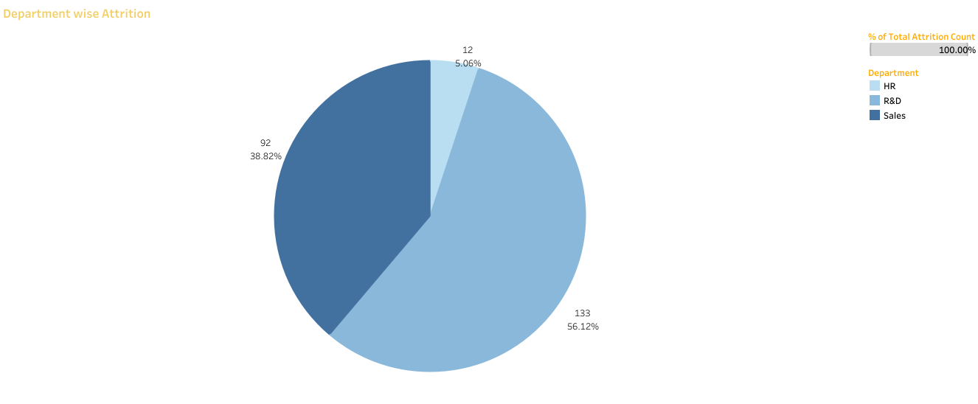

HR ANALYTICS STORELINE

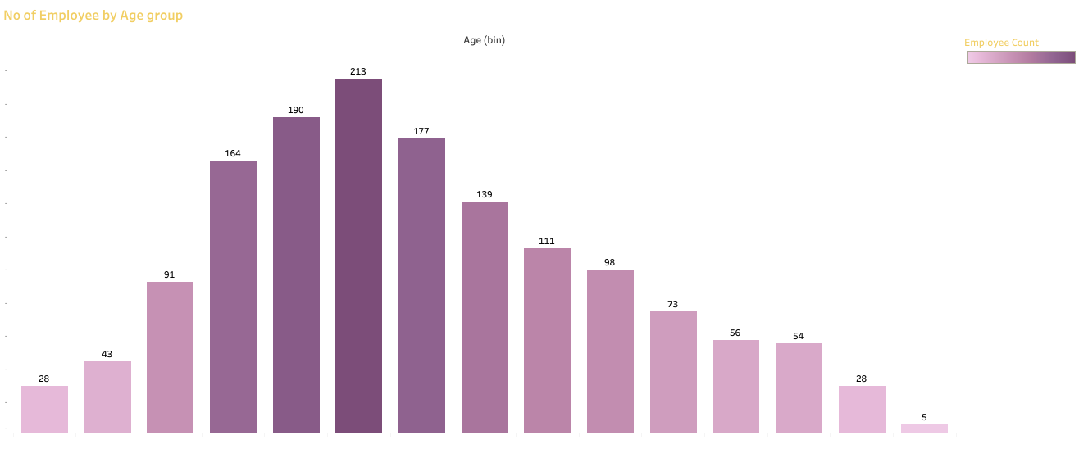

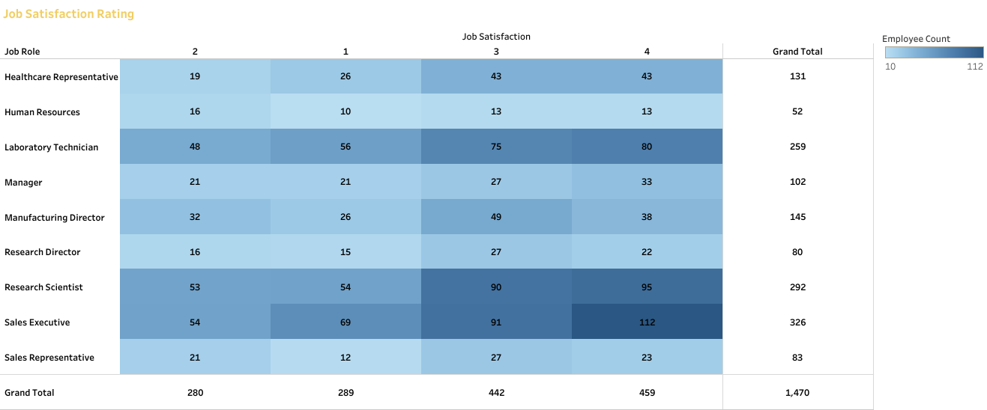

HR ANALYTICS STORE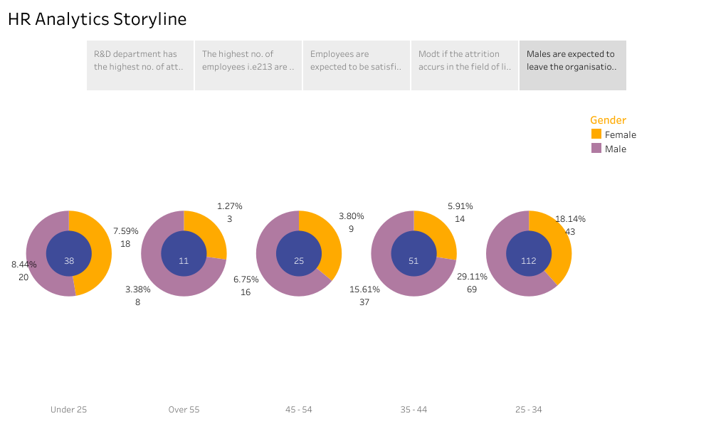

ADVANTAGES & DISADVANTAGES:

Advantages: 1. Data-Driven Decision Making: HR analytics allows organizations to make data-driven decisions when it comes to managing their workforce. By analyzing HR data, such as employee performance, engagement, and retention, organizations can gain valuable insights that inform strategic decisions.

2. Improved Hiring Process: HR analytics can help optimize the hiring process by identifying the most effective recruitment channels, improving candidate screening methods, andpredicting candidate success. This can lead to better quality hires and reduced turnover.

3. Employee Engagement and Retention: With HR analytics, organizations can identify factors that contribute to employee engagement and retention. By understanding what motivates and satisfies employees, organizations can implement targeted initiatives to improve engagement and reduce turnover.

Disadvantages:

1. Data Privacy Concerns: HR analytics involves collecting and analyzing employee data, which can raise privacy concerns. Organizations must ensure that they handle and protect employee data in compliance with privacy regulations and ethical standards.
2. 2. Data Quality and Accuracy: The effectiveness of HR analytics relies on the quality and accuracy of the data being analyzed. If the data is incomplete, outdated, or inaccurate, it can lead to flawed insights and decision-making.

5.APPLICATIONS

1. Recruitment and Selection: HR analytics can be used to identify the most effective recruitment channels, optimize candidate screening processes, and predict candidate success. This helps organizations make data-driven decisions to attract and select the best candidates.

2.Employee Engagement and Retention: HR analytics can help organizations understand the factors that contribute to employee engagement and retention. By analyzing data on employee satisfaction, feedback, and performance, organizations can implement targeted initiatives to improve engagement and reduce turnover.

1. Performance Management: HR analytics enables organizations to track and analyze employee performance data. This allows for more accurate performance evaluations, identification of high-performing employees, and targeted development plans to enhance individual and team
2. Diversity and Inclusion: HR analytics can help organizations measure and track diversity and inclusion initiatives. By analyzing data on representation, pay equity, and employee experiences, organizations can identify areas for improvement 6and implement strategies to foster a more inclusive workplace.

6.CONCLUSION

Some findings :

1. From this department wise attrition chart, it is clear that Research and Development i.e., R&D has higher rate of about 56.12%
2. From the representation of employees by age group, maximum is at the age of 32-34 of about 213 and least is 60 years and 5 employees is at the band.
3. 112 employees from Sales executive role rated 4 by their job satisfaction, 80 LaboratoryTechnicians follow the list while 69 Sales executive rate 1 for job satisfaction.
4. 89 employees are from LIfe Sciences background, Medical science scores second with 63 employees while 7 are from Human

Resource background.

1. 112 employees in 25-34 age groups are attired
2. FUTURE SCOPES:
3. Predictive Analytics: HR analytics will increasingly focus on predictive modeling, using historical data to forecast future outcomes.
4. 2. Artificial Intelligence and Machine Learning: AI and ML technologies will play a significant role in HR analytics
5. Talent Management and Succession Planning: HR analytics will continue to evolve in the area of talent management and succession planning. Advanced analytics techniques can help organizations identify high-potential employees, assess their readiness for key roles, and develop tailored career paths to nurture future leaders.
6. . Workforce Planning and Optimization: HR analytics will assist organizations in optimizing their workforce planning processes. By analyzing data on workforce demographics, skills, and performance, organizations can make informed decisions about workforce size, structure, and deployment to align with business goals.